STATE OF WISCONSIN MARATHON COUNTY TOWN OF CLEVELAND

RESOLUTION NO. 2026-01-13

A RESOLUTION TO CREATE THE INTERGOVERNMENTAL COMMITTEE

WHEREAS, the Town Board of the Town of Cleveland finds it in the public interest to study and make recommendations regarding relationship building between Town of Cleveland and the neighboring townships on issues which involve more than one of those townships;
'
WHEREAS, the Town Board desires to appoint an advisory committee to assist the Town Board with this
work; �

NOW, THEREFORE, BE IT RESOLVED, that the Town Bo·ard of the Town of Cleveland hereby creates

the "Inter-Governmental Committee" as an advisory com'
mittee to the Town Board;

BE IT FURTHER RESOLVED, that the Committee shall consist of 2 members, appoinfed by the Town
.. Chair and confirmed by the Town Board, who shall serve until the Committee's work is completed or until this resolution is amended or repealed;

BE IT FURTHER RESOLVED, that the Committee shall have advisory powers only and shall report its findings and recommendations to the Town Board as long as this resolution stands;

BE IT FURTHER RESOLVED, ttiat this resolution shall take effect immediately upon passage and publication/posting as required by law.

The town clerk shall properly post or publish this ordinance as required under s.9Q:8_Q, Wis. stats.

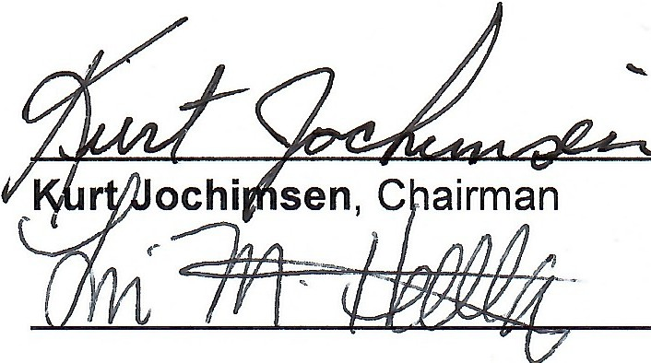
Passed and adopted this 13 day of 01, 2026, by the Town of Cleveland Board.

Lori Hollatz, Supervisor

•

•

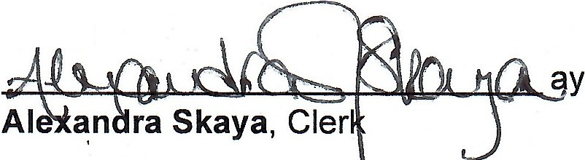
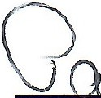
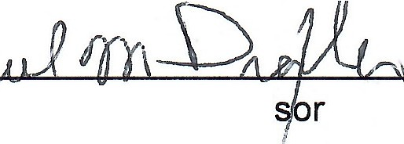
• •
At est:

Drexler, Supervi
'
Paul

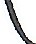

d
..
"

